COMPUTER PROGRAMMING

Name: HASHIR BEHRAM

Registration No: BF24NWELE0747

Section: A (Power)

Electrical Department

UET Nowshehra

LAB 4

LAB TITLE

Switch Statement, Break and Continue in C++

OBJECTIVE

The objective of this lab is to understand the use of the switch statement
in C++. Students
also learn how the break statement controls program flow and how the continue statement
is used inside loops. This lab also introduces simple menu
-
driven programs using switch
statements.

2.

THEORY

The
switch statement

is used when a program needs to select one option from multiple
choices based on the value of a variable. It is often used instead of multiple
if
-
else statements

when comparing a single variable with several constant values.

Each option inside the switch statement is written as a
case
. The program checks the value
of the variable and executes the matching case block.

The
break statement

is used to stop execution inside a case. Without break, the program
would continue executing the next cases.

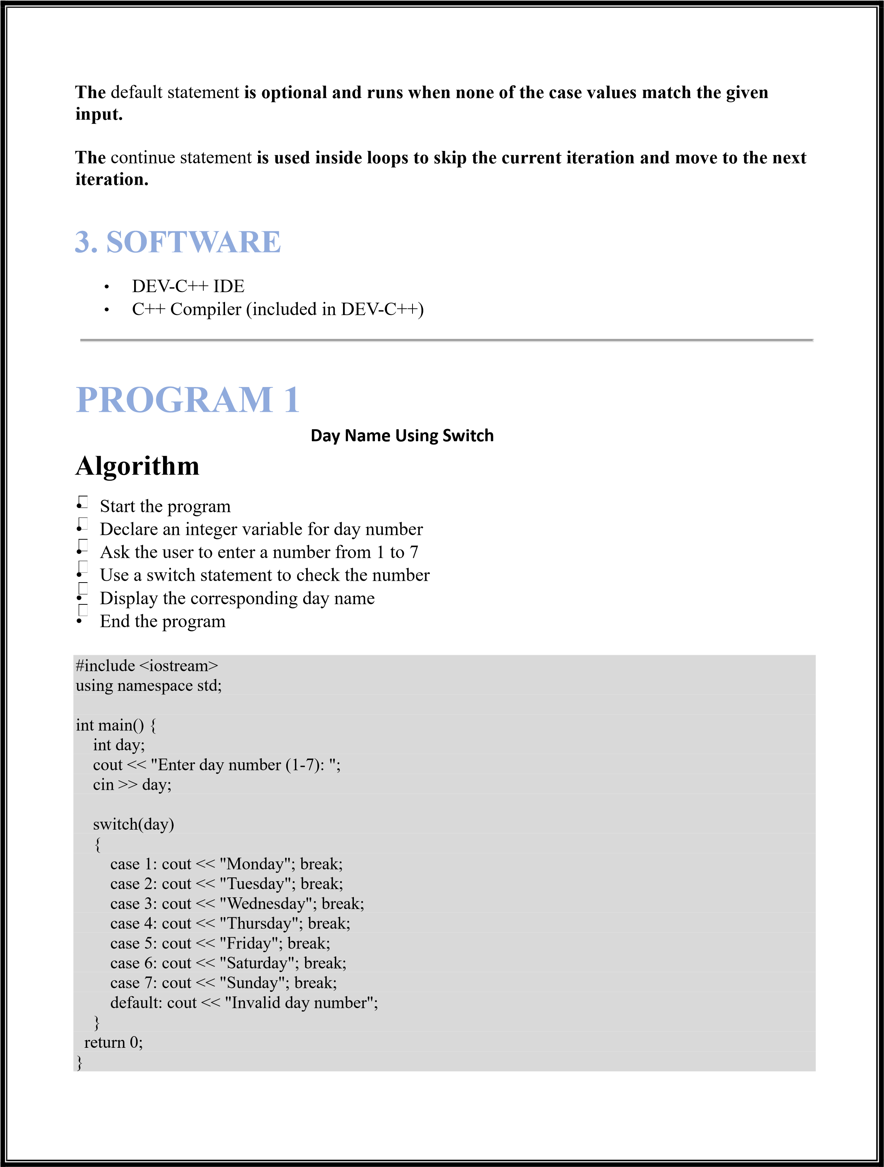

PROGRAM 2

Grade Evaluation Using Switch
Algorithm


- Start the program

- Declare a character variable for grade


- Ask the user to enter a grade

- Use a switch statement to evaluate the grade

- Display the corresponding message
- End the program

#include <iostream> using namespace std;
int main()
{
char grade; cout << "Enter your grade (A, B, C, D, F): "; cin >> grade; grade=toupper(grade);
switch(grade)
{ case 'A':
cout << "Excellent";
break; case 'B'; cout << "Very Good"; break; case 'C':
cout << "Good";
break; case 'D':
cout << "Pass"; break; case 'F': cout << "Fail"; break; default:
cout << "Invalid Grade";
}

return 0;
}
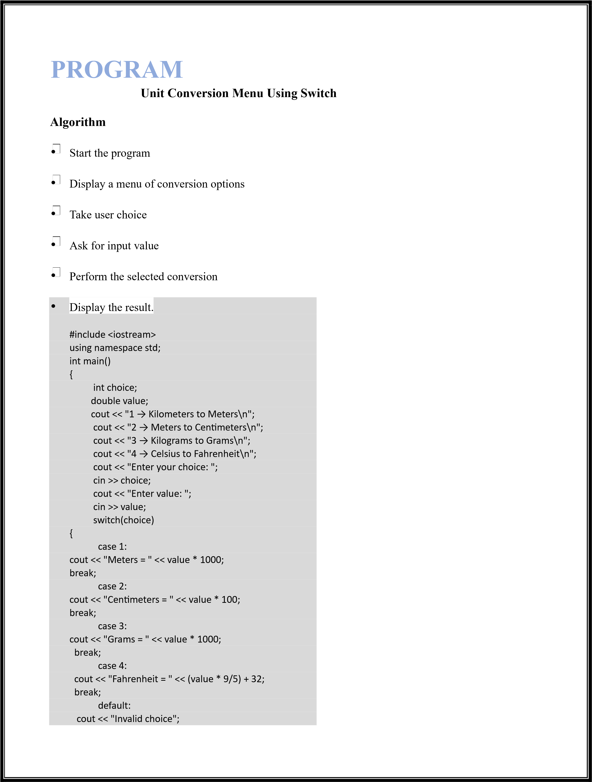
}

return 0;

}

C
onclusion

In this lab we learned how to use the
switch statement

for multiple decision making in C++. We
also understood the importance of the
break statement

in controlling program flow. This lab
helped us develop simple menu
-
based programs and improved our understanding of conditional
structures.

